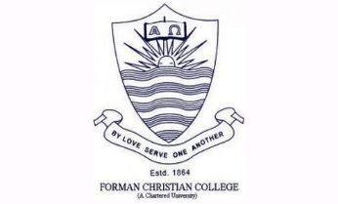Forman Christian College

Addendum to the 4-Year Bachelor’s Degree Program Catalog 2021-22 Effective 08/06/2023

This document serves as an addendum to the 4-Year Bachelor’s Degree Program Catalog 2021-22 to provide the policies and procedures related to the Bachelor’s programs. It should be noted that these policies and procedures outlined herein are in addition to any and all applicable policies in the 2021‐22 Catalog.

Section: Requirements of the Major (Page 148-149)
Department of Mass Communication
Requirements for the Major: Requirements for the Major 48 credit hours including the CORE COURSES mentioned below (6 core + 10 electives) MCOM 201, MCOM 301, MCOM 414, MCOM 409, MCOM 499, MCOM 498(mandatory internship). In case of specialization 6 core courses, 5 specialization courses and 5 elective courses.

